Quick Start Guide To
Mobility Tool+
For Key Action 2 Strategic Partnerships
Version 3

Contents
Introduction 3
1. Log In 4
2. Check Your Project Details 5
3. Check Organisations/Partners’ details 5
4. Add additional users to Mobility Tool+ / update user contact details 6
5. Project Management and Implementation 7
6. Transnational Project Meetings 7
7. Intellectual Outputs 8
8. Multiplier Events 9
9. Learning, Teaching and Training Activities 9
10. Special Costs 12
11. Other Project Events 13
12. Check your budget section 13
13. Complete your final report 14
14. Submit your final report 16
15. Partnership Dashboard 16
16. Project Results Platform 17
17. Next Steps 17
18. Contact us for more help 18

Introduction
This step by step guide has been produced by the UK National Agency to help beneficiaries of Key Action 2 Strategic Partnerships projects. If you still need assistance, please do not hesitate to contact us.
We advise using Google Chrome or Mozilla Firefox as your internet browser. Some functionality is lost when using Internet Explorer as your browser.
Coronavirus Guidance
The UK National Agency has produced a guide to help institutions process Key Action 103, 107 and 203 Force Majeure cases (976 KB), due to Covid-19. Please note that it is based on information available to the UK National Agency to date and subject to change, considering that the current situation is still evolving. This document is intended as a guide for processing a wide range of scenarios, and while it may not be exhaustive, it provides an understanding of how to use the Force Majeure function on the Mobility Tool+ and record mobilities affected by Covid-19.
What is Mobility Tool+?
Mobility Tool+ is the system that allows Erasmus+ & European Solidarity Corps beneficiary organisations to access and manage their project information, such as encoding activities and participants, request individual participants' reports and submit final reports to their National Agencies. National Agencies also use Mobility Tool+ to monitor and validate information entered by beneficiary organisations at any time from anywhere. Mobility Tool+ is designed, developed and maintained by the European Commission and being used by beneficiary organisations and National Agencies involved in decentralised projects. The management of the project and its contents is the responsibility of the Beneficiary Organisation users. Contacts defined in the electronic application form as contact persons and legal representatives for the applicant/beneficiary organisation will automatically have access to their corresponding projects in Mobility Tool+. This happens when the project's data is submitted from the NA's Project Management System. National Agency users can also have access to the Mobility Tool+ for monitoring and validation purposes.

Log In
The official contact and legal representative for your Erasmus+ project (as per the most up-to-date details on the UK National Agency database) will receive an automated email when your organisation’s Erasmus+ project has been added to Mobility Tool+.
In order to log in to Mobility Tool+ you need to have an ‘EU Login’ account. EU Login is a service that allows users to access digital systems developed or used by the European Institutions. If you already have an EU Login account, please log in and proceed to step 2.
If you do not have an EU Login account, please follow the instructions below to register. Open the following link: https://webgate.ec.europa.eu/cas/eim/external/register.cgi to access the registration page to enter your details.
Please ensure that you
- complete all fields;
- read and accept the privacy statement by checking the box; and
- complete the security check by typing in the characters on screen. If the characters are not clear enough, click the icon to try a different image or click the icon for an audio version.
After clicking the ‘Create an account’ button, an automatic email will be sent through to the email address you used to register. This email contains your username and a link to create your password. You must create a password within 90 minutes of receiving the email. If you are required to specify your Domain Name when completing the form, you should ensure that you choose ‘External’. Further guidance for registering with EU Login is available on the Erasmus+ website.
Once you have registered, you will be able to log in to Mobility Tool+. In order to do this, please click here or follow this URL address: https://webgate.ec.europa.eu/eac/mobility .
Two-Factor Authentication
Since June 2020, some of the European Commission’s platforms require users to register a second method of authentication. This is required as a security measure for all users of the NAconnECt, IT documentation, Programme Committee Wikis and Erasmus+PRP platform.
The recommended two factor authentication methods for accessing NAconnECt and the Programme Committee Wiki are:
- EU Login Mobile App: PIN code
- EU Login Mobile App: QR code
In order to continue having access to NAconnECt Wiki and Programme Committee Wiki, you will need to install and initialise the EU Login Mobile App on your mobile or tablet. The EU Login Mobile App is free of charge and can be obtained from the Google Play Store (Android), the App Store (iOS) or the Windows Store (Windows Phone). These verification methods will not require you to share your personal mobile number.
For instructions on how to install and initialise the App, please see page 12 of the EU Login Tutorial.pdf. Guidelines on how to use either of the verification methods can be found on pages 5 (PIN code) and 6 (QR code).
Please note: You will need to enable notifications on your device for this app. Disabling notifications will prevent the app from being able to authenticate the installation and access to the website.

Check Your Project Details
When logging in to Mobility Tool+ you should select your project number. Once you have done this you should see a page that looks like the picture below. Your organisation’s details should be pre-filled. Please check all details carefully. If anything is incorrect, please let us know as soon as possible.
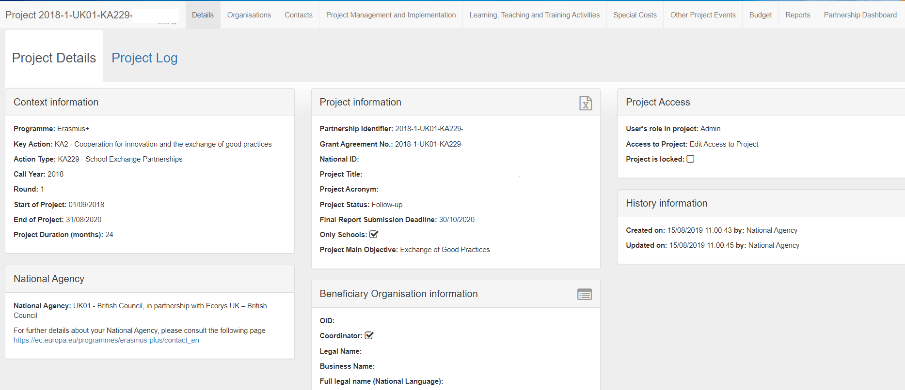

Check Organisations/Partners’ details
If you wish to check the details for the different organisations that take part in your project:
- Select from the top toolbar
- A list of organisations will appear, click in order to access their details.
- Click the grey square under “contacts” to be redirected to the section where only the selected organisation’s contacts are displayed.
Please note that these sections are greyed out and can only be modified if the organisations change their Organisations ID (OID) details through the Organisation Registration System.
The Organisation Registration System is your entry point for the electronic administration of EU-funded projects under programmes, such as Erasmus+. It is open to beneficiaries managing their EU grants to view and edit their organisational data, such as bank details or LEAR (Legal Entity Appointed Representative). A LEAR can, for example, be an administrative staff with access/rights to keep the ORS up to date, so please do not mistake this with Legal Representative.
The 8-digit OID, which is prefixed with an E, is obtained and managed through the Organisation Registration System. When the contact person leaves the organisation without appointing another person, the access to update the OID is lost. An organisation can always request a password reset; however, this only works when the person forgets the password. If the person left the organisation, in most cases, the organisation does not have access to the email address any longer so a password reset will not help. Therefore, it is recommended for each organisation to have at least two people with access to OID to ensure there is a backup.
For more information please visit the Organisation Registration System here.

Add additional users to Mobility Tool+ / update user contact details
If you do not need to add further users, please proceed to step 5. If you would like to add additional users or edit existing users’ details, please follow these steps:
- Select from the top toolbar.

You should now see a list of people who currently have access to your project.
- To edit someone’s details select next to their name, update details and save.
- To add a new contact select 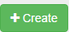
- Enter their details.
- Select the access to project button and save. You can choose to give the new contact access to edit or view the project.
- The new contact should now be shown in your contacts list. They will now receive the automated login email to confirm access. They will also need an EU Login account (See Step 1: Log in).

Please note: Only those contacts showing an “E” under the “access” column will be able to modify the information on Mobility Tool+. The Legal Representative of the project will not have automatic edit access and the coordinator might wish to change their access rights.

Project Management and Implementation
This section shows the allocated budget for each partner.
If not pre-populated, please type in the ‘Project Management and Implementation’ budget for each organisation involved in the project. This should be input in the ‘Total’ box, which can be edited by clicking on.
As this amount is calculated based on a monthly rate, you will need to enter the amount that was awarded to you or a portion of it if you are submitting your report early (in the case of interim reports, for example). You can find the applicable rates in the Erasmus+ Programme Guide for your project’s call year.
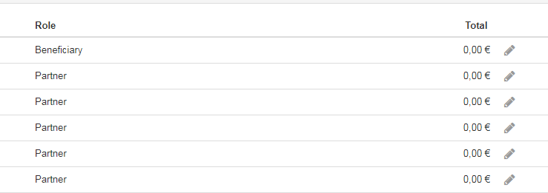
Please note: School Exchange Partnership projects (KA229) will only need to input the figures for their own organisation.

Transnational Project Meetings
In order to add Transnational Project Meetings on Mobility Tool+, you will need to:
- Select 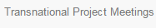 from the top toolbar.
- Select 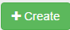 to add a new Transnational Project Meeting.
- You will need to input the ‘Meeting Title’, Start and End dates and the ‘Receiving Organisation’ fields. The ‘Receiving Country’ and ‘Receiving City’ fields will self-populate once the receiving organisation has been selected from a dropdown list.
- Check and click . The participant section should appear underneath the button once it has been clicked.
- Select to add new participants. You will be redirected to the Participant Form. You can also use the search bar to look for existing participants.
- Please complete the different fields with the appropriate details. You will need to use the EU Distance Calculator to work out the distance band for the participants of each organisation. The grey areas will self-populate once the necessary information has been inputted.
- Once completed, please check all the details carefully and click .

Please note: This section does not apply to School Exchange Partnership (KA229) projects and will, therefore, not appear on the top bar.

Intellectual Outputs

Please note: This section should only be completed by projects supporting Innovation and does not apply to Key Action 229 (School Exchange Partnership) projects.
In order to add Intellectual Outputs on Mobility Tool+, you will need to:
- Select from the top toolbar.
- Select to add a new Intellectual Output.
- You will need to input ‘Output Identification’, ‘Output title’, Start and End Dates, the Available Languages (Only Language 1 is compulsory), the Available Media (only Available Media 1 is compulsory) and the ‘Description of the Intellectual Output.
- Check and click . The ‘Organisation’ section should appear underneath the button once it has been clicked.
- The new screen should appear on your computer. Please fill in all the blank fields in order to allow Mobility Tool+ to calculate the value for the grey fields.
- Once completed, please check all the details carefully and click
- Add as many rows as needed in order to show the organisations that have worked on each Intellectual Output and the number of days they have spent working on it.
Please note: Whilst Mobility Tool+ will prepopulate some of the information relating to the Intellectual Outputs, you should provide the most up to date information, including updating the description of the Intellectual Outputs as they are finally developed.

Multiplier Events
Please note: This section should only be completed by projects that have created Intellectual Outputs.
All Innovation projects must be disseminated effectively in order to guarantee maximum impact. This section allows beneficiaries to input all the details about the Multiplier Events that have been used to showcase the Intellectual Outputs. To add a Multiplier Event:
- Select 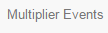 from the top toolbar.
- Select to add a new event.
- Please fill in all the blank fields (Event Identification, Event Title, Country of Venue, Description of the Multiplier Event, Intellectual Outputs Covered and Start and End Dates).
- If your Multiplier Event was delivered virtually, please tick the Virtual Event box 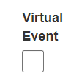
- Once these have been completed, please click and the Budget section will appear.
- Please click on the button or use the search bar to find existing information.
- Complete all the blank fields for the different sections (Organisation, Number of Local Participants and Number of International Participants) in order to allow the Mobility Tool+ to calculate and self-populate the grey fields. Please click 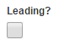 if the hosting country is leading.
- Check all details have been added carefully and click .

Learning, Teaching and Training Activities
Please input the information for all the Learning, Teaching and Training activities in the project. In order to do this please:
- Select 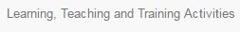 from the top toolbar. You will then be able to see the activities included in the project.
- Select to add a new activity (if they are not displayed already).
- Please fill in all the blank fields (Activity number, activity type and description of the activity). Please click if this was a long-term activity.
- Once these have been completed, please click and the Participants section will appear.
- Please click on the button or use the search bar to find participants’ information.
- Complete all the blank fields for the different sections in order to allow the Mobility Tool+ calculate and self-populate the grey fields.
- Check all details inputted carefully and .
Please note: You should always use the European Commission’s Distance Band Calculator when completing this section, in order to ensure accurate reporting.

Force Majeure
If one of your mobilities has been affected by an unforeseeable event, such as the Coronavirus outbreak and had to be cancelled, the first step to take is to try to recover funds through your insurance provider or other refund method form the airlines, course and accommodation providers. However, if this is not possible, you may be able to claim Force Majeure.
Force Majeure is defined as an unforeseeable exceptional situation or event beyond the participant's control and not attributable to error or negligence on his/her part (as per page 321 of the 2020 Erasmus+ Programme Guide)
If you request to claim Force Majeure by ticking the relevant box, you will be required to provide reasons as to why this should be considered as such. Please provide as much detail as possible as these claims will be assessed on a case by case basis. You can find the box for comments at the bottom of the screen.
Covid-19 and Force Majeure
If your mobility was impacted by the Coronavirus outbreak, and this is indicated on your Force Majeure claim, the box below will be automatically ticked. This will allow the UK National Agency and the European Commission to identify the impact of the outbreak on projects. In order for this box to be automatically ticked, you will need to provide comments at the bottom of the screen in regard to the reasons for your Force Majeure claim. You will need to mention either “corona” or “covid” in your description to trigger this.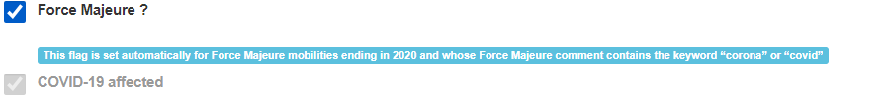
Please note: If you are unsure about any of the terms used, you can click on , which can be found on the top right-hand corner of the section and will provide more detailed explanations in regard to what you need to answer in each field.
How to report a partial recovery through Force Majeure
If one of your activities was cancelled due to Covid-19, you should try to recover the funds through your insurance or the different providers first of all. If you were unable to recover all of the costs, you would apply for Force Majeure for the full unit costs. However, if you have managed to recover part of the costs incurred, you will need to:
- Go to the “Learning, Teaching and Training Activities” tab
- Follow steps A – C outlined in section 9 of this guide
- Tick the “Force Majeure” field -
- Follow steps E – F outlined in section 9 of this guide
- The grant amount will not calculate automatically and you will need to enter the specific amount you need to request under “Individual Support Total Grant for Participants/Accompanying persons” as per the image below.

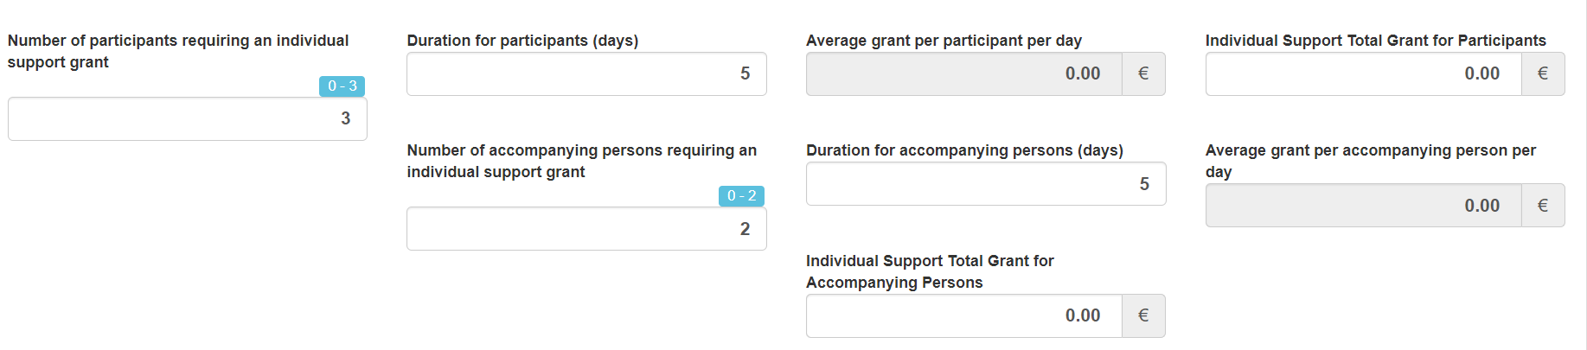
- Repeat this steps in the “Travel Grant” sections -
- Save the activity .

Special Costs
Please select the relevant category, as this will show specific questions for each category
In order to input any Special Costs on Mobility Tool+, follow these steps:
- Select 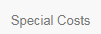 from the top toolbar.
- Select
- Please select the relevant category for the costs you are entering.
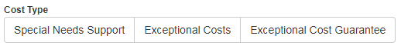
For Special Needs Support
- Select from the top tool bar
- Fill in all the blank fields (Organisation, Number of Participants with Special Needs, Grant Requested and Description and Justification).
- Check the details carefully and click .
Please note: These are real costs (not calculated using unit rates). You will need to attach the invoices / receipts for Special Needs Support within the final report.

.
For Exceptional Costs
Exceptional Costs must have been previously approved by the National Agency. In order to input information regarding Exceptional Costs:
- Select from the top toolbar.

- Please fill in all the blank fields (Organisation, Total Incurred Cost, and the Description and Justification). This will trigger the self-populating option for the grey fields, which will provide you with the actual costs.
- Check the details carefully and click .

Please note: These are real costs (not calculated using unit rates) and that they must have previously been approved by the National Agency. You will need to attach the invoices / receipts for Exceptional Costs within the final report.

For Exceptional Costs Guarantee
Please complete this section only if this type of cost was previously agreed with the UK National Agency.
- Select 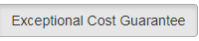 from the top toolbar.

- Please complete the blank fields (Organisation and Total Incurred Cost). This will trigger the self-populating option for the grey field, which will provide you the actual costs.
- Check the details carefully and click .
Please note: Every time you click save you will be redirected to the home page of the “Special Costs” section. Therefore, you will need to click every time you wish to add a new Special Cost.

Other Project Events
In this section, you will need to add all other activities that are not included under Transnational Project Meetings, Learning, Teaching and Training Activities, Intellectual Outputs or Multiplier Events. These are activities where no funding is being claimed as they are covered by the Project Management and Implementation budget or by the organisation. Some examples of these are dissemination activities, local events organised by the partnership or regular management meetings.
In order to enter these activities you will need to:
A. Click
B. Complete all mandatory values, including type of activity (e.g. Meeting, dissemination activity, etc.), the dates when this activity took part and a short description of the activity.
C. Check the details carefully and click .

Check your budget section
The Budget section provides a summary of the financial details of the project against each of the budget headings. This section displays your project’s current budget based on the information you have entered into Mobility Tool+ as well as your budget approved by the UK National Agency.
Please regularly check the Budget section to help you financially manage your project and any budget category transfers that you have informed the National Agency about. For this purpose, Mobility Tool+ also includes a column which displays the percentage of your current budget against the approved budget. If you go over your approved budget for any heading, the amount will be shown in red.
- Select from the top toolbar.
- Check that the “Current Budget (in Mobility Tool)” reflects the amount you have spent so far.
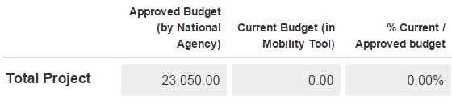
If you wish to hide the columns that show the funds that you could transfer between categories, please click on on the top right handside of this screen,

Complete your final report

- Select 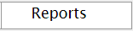 from the top toolbar.
- Select 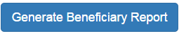
- Select
- Complete the narrative sections of the form until all the left toolbar is completed with green ticks

- When you have completed all narrative questions please upload your supporting documentation in the annexes section at the bottom of the page. Only the items listed below should be uploaded in this section, due to its size limit. All other supporting documentation should be, as appropriate, uploaded to the Project Results Platform or kept for submission in the event of an audit.

Please note: For Key Action 2 projects, you will need to submit the following attachments:
- Report Declaration of Honour – This can be downloaded within your report (please see step G).
- Receipts and invoices for Special Costs – including translations of these if the originals are not in English and clearly stating the costs incurred.
- For youth projects (KA205) you will also need to submit a project timetable as an attachment.

- You can find the Beneficiary Declaration of Honour in the “Annexes” section of your narrative report. You should “Download PDF”, print it and get the legal representative of your project to sign it. You must then scan and upload it as a file using the “select file” button. You can upload all other supporting documentation here, using the “select file” button.
- Once you are happy with your final report and all documentation is uploaded as an annex you should press the “start the submission process” button at the top of the page.
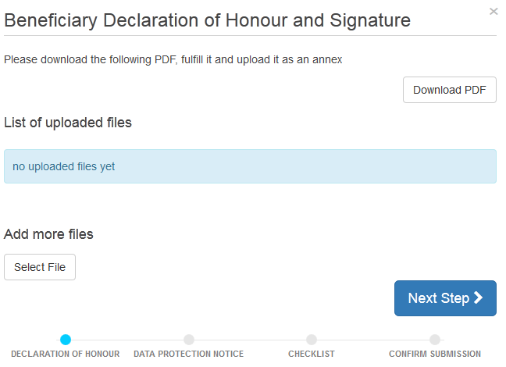
- Once your Declaration of Honour is uploaded select 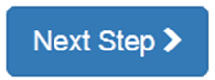
- Please then read the Data Protection Notice and select 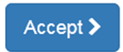Go through the check list carefully. When you are satisfied you have completed each step click the button. This should turn the button green and to 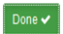
- Once you have completed the check list select 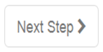

Submit your final report
You can submit your final report using the 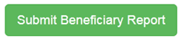button. Once you submit your final report, you will no longer be able to access your project in Mobility Tool+. Please check the report content before submitting.
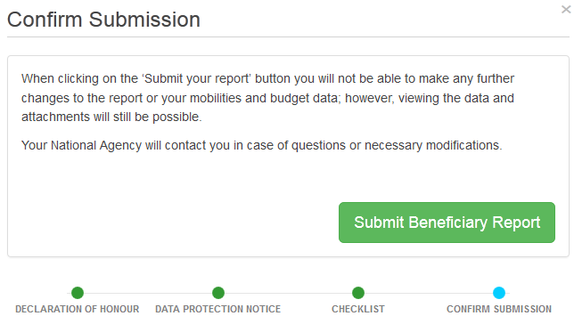

Partnership Dashboard
In the case of School Exchange Partnership Projects (KA229), the lead organisation will be able to see a 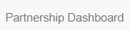 tab. By clicking here, they will be able to see whether their partners have submitted their own reports and will be able to manage these (e.g. checking information provided). The reporting process for KA229 projects should follow three steps:
- The lead school will enter all activities onto Mobility Tool+ and complete the narrative report. Once this has been completed, the lead school marks the report as ready for submission.
- At this point, all other schools in the partnership must finalise their part of the report and confirm that they agree with the information provided by the coordinator. Once they are ready, the partner schools also declare they are ready for submission.
- Once all organisations declare that they are ready, the lead school will submit the final partnership report for assessment by the National Agency.

Project Results Platform
Please note that all Key Action 2 projects are contractually required to upload all of their project results onto the Project Results Platform. The information provided here will be assessed together with the narrative report submitted through Mobility Tool+. Therefore, this information should be detailed and include evidence of these results (i.e. links to a website, videos, etc.) in order to provide evidence of the project’s outcomes.
Please note: You should clearly mark the project’s Intellectual Outputs as such and label them in a manner that is relatable to the project activity.

If you require any support with this platform, please contact the European Commission at EAC-ProjectsPlatform-HelpDesk@ec.europa.eu
Please note: Only the originally listed Contact Person for the lead organisation will have access to this platform. Any additional contact requests for this platform will need to be submitted directly to the European Commission at the above-mentioned email address.

Next Steps
Once your report has been assessed we will notify you of the next steps.
The amount of the final payment to be made to you will be established on the basis of your final report. If a) the events generating the grant are not implemented or are implemented in a different way than planned; or b) the eligible costs actually incurred by the beneficiary are lower than those planned at application stage, or c) the quality of the realised activities/outputs is of insufficient quality, the funding may be reduced proportionally or, where applicable, your organisation may be required to repay any excess amounts already received as pre-financing payment.
As part of the UK NAs assessment of your Final Report we may contact you for clarification of certain areas of your report. In the event that such contact is made it is requested that you respond at your earliest convenience so you may receive your Final Payment at the earliest opportunity.
As a general rule, the final payment or request for recovery of the balance will be issued within 60 calendar days of the receipt of the final report.

Contact us for more help
The Erasmus+ Team is on hand to help you with any queries you may have whilst completing your report. Contact us:
Schools:
- Phone +44 (0) 161 957 7755. Our helpline is open Monday – Friday. 08.30 – 17.30 (excluding public holidays).
- Email at erasmusplus.schools@britishcouncil.org.
Higher Education
- Phone +44 (0) 161 957 7755. Our helpline is open Monday – Friday. 08.30 – 17.30 (excluding public holidays).
- Email at erasmus@britishcouncil.org
Youth
- Phone +44 (0) 161 957 7755. Our helpline is open Monday – Friday. 08.30 – 17.30 (excluding public holidays).
- Email at erasmus.youth@britishcouncil.org

By using this guidance document, you accept this disclaimer in full. This guidance document has been produced solely for Erasmus+ Key Action 2 beneficiaries and no other reason and therefore should not be relied upon by any third party. The contents of this guidance document are not advice and should not be treated as such. Neither the United Kingdom National Authority function for the Erasmus+ programme (the “National Authority”) nor the United Kingdom National Agency function for the Erasmus + Programme (the “National Agency”) nor any person acting on their behalf may be held responsible for the use which may be made of this guidance document and any information contained in this guidance document. The National Authority and the National Agency have not verified, nor do they make any representations or assurances as to, the quality, nature of, efficacy or otherwise of this Handbook or as to the accuracy, completeness or adequacy of any information contained in this guidance document. Should you wish to use the materials in this guidance document, you agree to acknowledge that the materials were originally developed by the National Agency for the UK Erasmus+ Programme.

